**LAB 5: STATIC ROUTING**

**THEORY**

Routing refers to choosing the best path for data to travel from one device to another across a network. When a computer sends data to another device, that data might pass through multiple routers. Routers use routing to decide which path the data should take to reach its destination quickly and efficiently. This decision is made using a routing table, which holds information about different networks and directions. a commonly used method is static routing

**Static Routing**

In static routing, network routes are manually entered into the router by a network administrator. These routes remain unchanged unless the administrator changes them. Static routing is simple and uses fewer resources, making it suitable for small or fixed networks where the paths between devices do not change often. However, it does not automatically update if a link fails, which can cause communication problems unless the settings are corrected manually. Despite this, static routing is reliable and easy to set up for basic networks.

**Syntax:**

Router(config)# ip route <des_network_id> <subnet_mask> <next_hop_ip>

where, des_network_id – The network you want to reach (e.g., 20.0.0.0)

subnet_mask – The subnet mask for that network (e.g., 255.0.0.0)

next_hop_ip – The IP address of the next router (gateway) that can forward the packet to the destination network (e.g., 40.0.0.2)

**Lab Setup**

In this lab, we designed a multi-router network topology in Cisco Packet Tracer using 1941 routers and 2960-24TT switches. The network consists of four routers (Router0 to Router3) connected in a triangular serial configuration using Serial DCE/DTE links. Each router is connected to a local switch, and two PCs are connected to each switch, simulating end devices at different branch

locations. We used Gigabit Ethernet ports (Gig0/0, Gig0/1) to connect routers to switches, and Serial interfaces (Se0/1/0, Se0/1/1) for router-to-router communication.

We configured IP addresses for all interfaces on the routers to ensure proper network segmentation and communication between devices. Additionally, we defined default gateways on each PC to point to their respective router interfaces, allowing the PCs to send data beyond their local network. This setup enables end-to-end connectivity across different networks. This lab primarily aims to practice static routing, where routes are manually configured on each router to define the paths for data packets. This helps in understanding how routing decisions are made without relying on dynamic protocols.

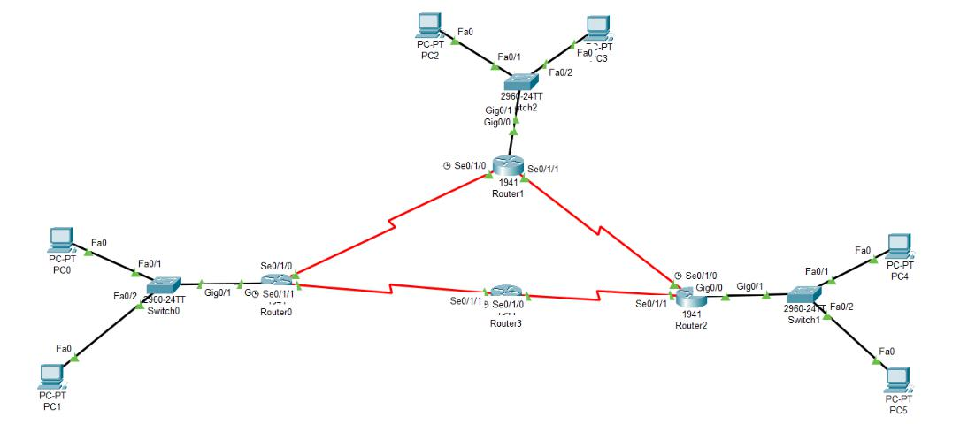

In this lab, we created a network setup in Cisco Packet Tracer using four 1941 routers, three 2960-24TT switches, and six PCs. Each switch was connected to two PCs and one router using Ethernet cables, while the routers were connected to each other using serial cables for inter-router communication.We began by selecting each router and going to the "Config" tab. Then we clicked on the interfaces one by one (such as `GigabitEthernet0/0`, `Serial0/1/0`, etc.) and entered the appropriate IP address and subnet mask into the provided fields. For interfaces where we used serial DCE cables, we also set the clock rate to 64000 by selecting the option in the interface settings. After that, we made sure each interface was turned ON by clicking the "On" button.

Similarly, we clicked on each PC, went to the "Desktop" tab, then opened the "IP Configuration"

window, and entered:

* The IP address of the PC

* The subnet mask (usually 255.255.255.0)
* The default gateway, which is the IP address of the connected router's interface

This enabled all devices on the network to recognize each other and communicate. After completing all configurations, we used the ping tool to verify connectivity to test communication between PCs on different networks. This demonstrated that the network was correctly set up using IP addressing and static routing through the graphical interface.

For example: only GigEthernet0/0, Se0/1/0, and Se0/1/1 was connected to the Router0. So,

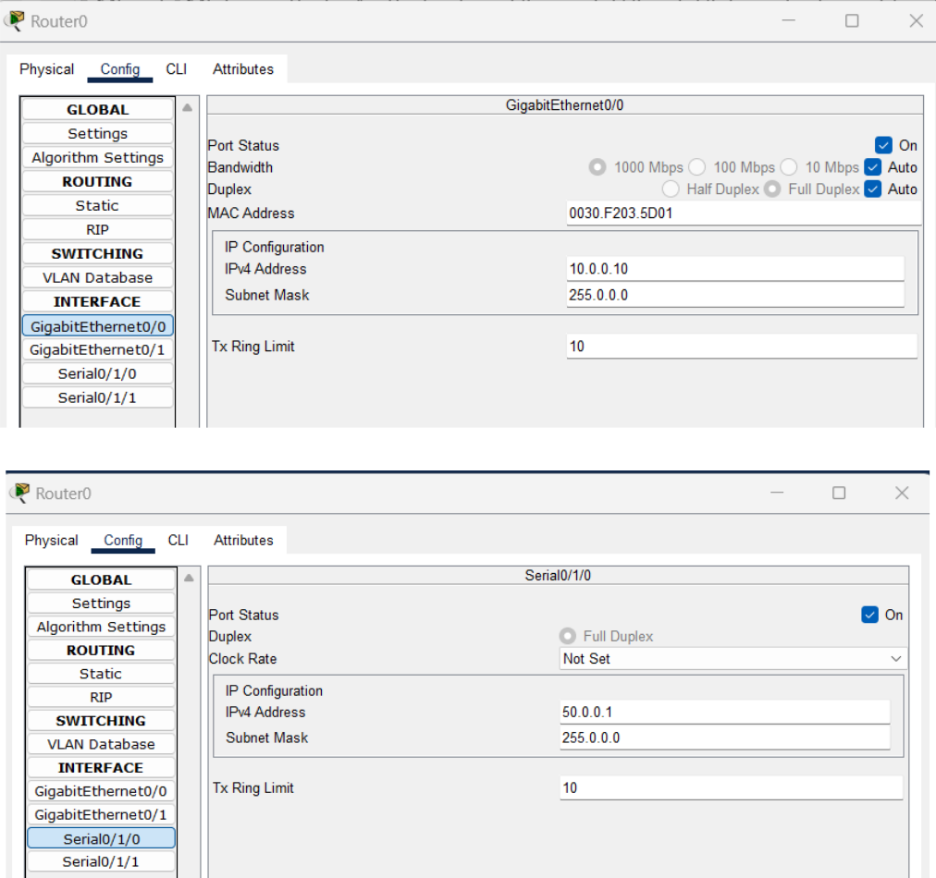

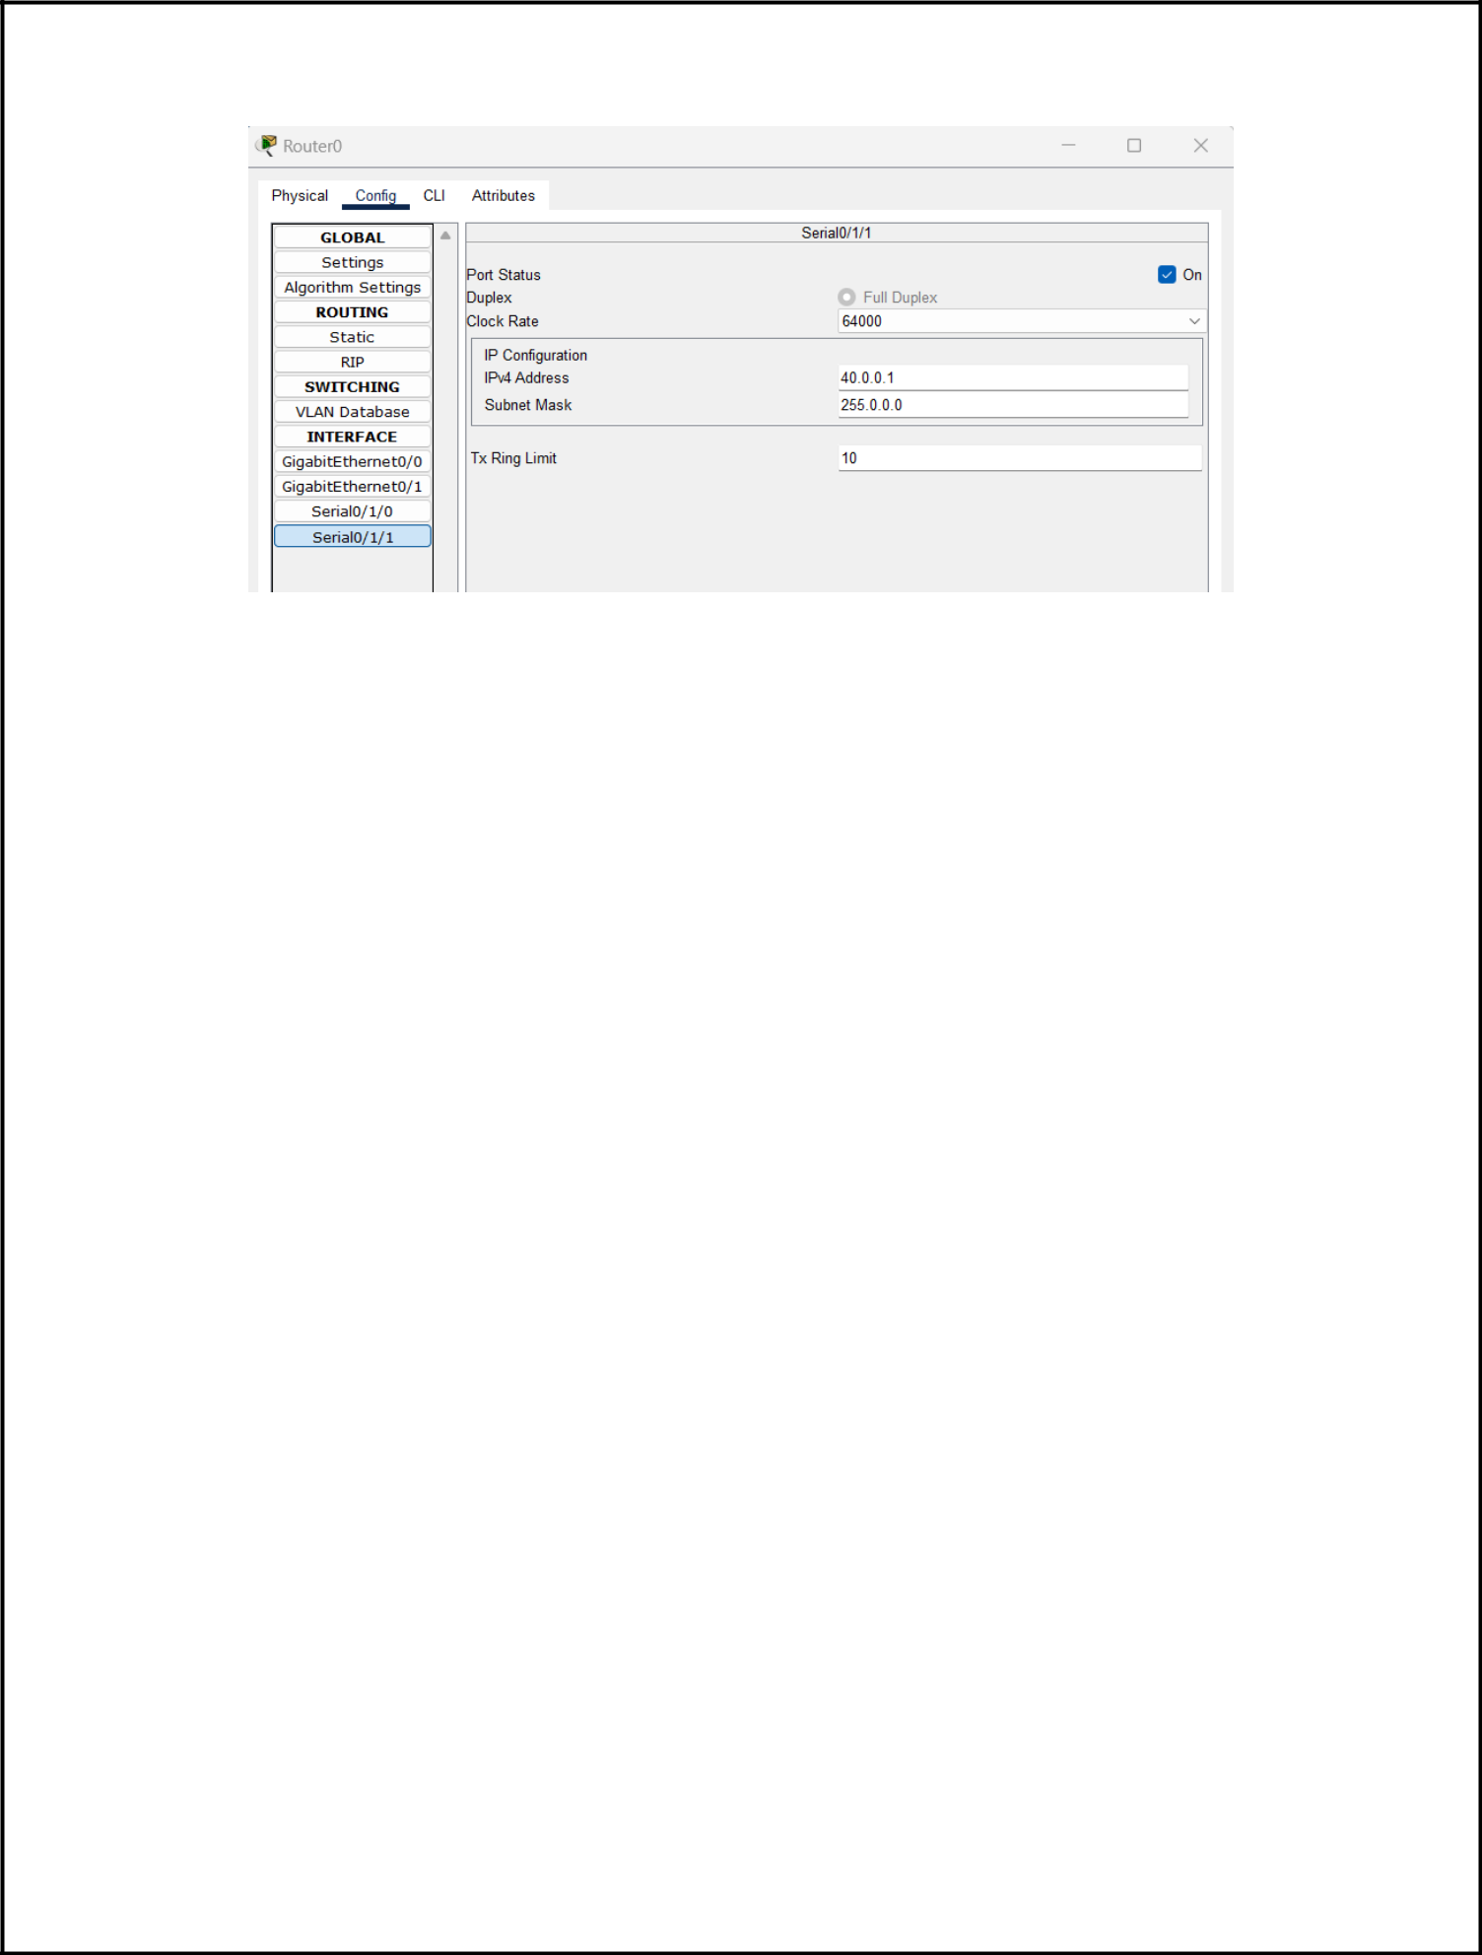

Similarly, these processes were repeated for Router1, Router2, and Router3

After completing the initial configuration, we attempted to send a ping from one PC to another located in a different network. However, the result showed a “Destination host unreachable” error. This error usually means that the packet could not be forwarded beyond the source network.

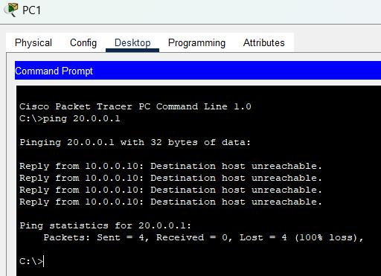

The most common reason for this issue is missing or incorrect static routes on the routers. Although IP addresses and default gateways were correctly assigned, the routers did not yet know the full path to all other networks. Since we were using static routing, each router needs to be manually told about all other networks it cannot directly reach. Without these static routes, routers drop the packets instead of forwarding them, causing the ping to fail. To fix this, static routes must be added to each router’s routing table so they know where to send packets destined for external networks.

**Solving the error from the ping**

To solve the issue of failed pings and unreachable hosts, we configured static routes on the routers using the command line interface. Static routing is used to manually inform routers about networks they are not directly connected to. Without these routes, routers would not know where to forward packets for unknown destinations, which leads to errors like “Destination host unreachable.” In our setup, for example, one of the routers was configured with a route to reach the 20.0.0.0 network via the next-hop IP address 40.0.0.2. This means that any data meant for the 20.0.0.0 network would be sent to 40.0.0.2, which then forwards it to the correct destination. Similarly, other routes were added to reach the 30.0.0.0, 60.0.0.0, and 70.0.0.0 networks through their respective next-hop addresses. After adding all necessary static routes, the routers were able to communicate with each other and the PCs across different networks could successfully ping each other, confirming full connectivity.

**For Router0,**

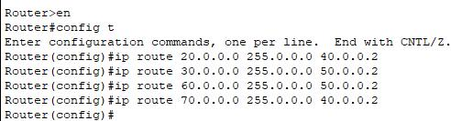

**For Router1,**

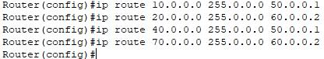

**For Router2,**

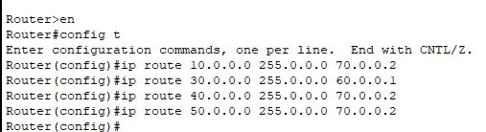

**For Router3,**

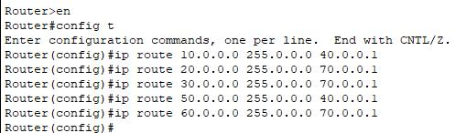

**Successful Ping Test to Verify Inter-Network Connectivity**

After completing all the configurations, including assigning IP addresses, setting gateways, and adding static routes on the routers, a ping test was performed from 10.0.0.1 to 20.0.0.1. The ping was successful, meaning that all four packets sent were received back with 0% packet loss.This success confirms that the network is fully connected and working properly. It also proves that the routers were able to forward the packets correctly across multiple networks using the static routing entries we added earlier. Each router in the path knew exactly where to send the data, and the destination device was able to respond. The round-trip time values (13ms to 17ms) show that the communication was smooth, without delay or errors. This proves that our routing configuration was correct and that all devices in the network can now talk to each other without any issues.

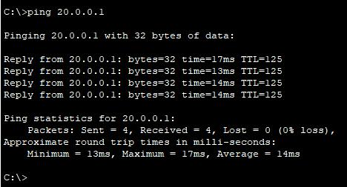

**Tracking the path**

After successfully configuring the network and ensuring that static routing was working, we used the tracert command (short for "trace route") to check the exact path that packets took to reach the destination IP address 20.0.0.1. This command helps in identifying the hops or routers that the packet passes through from the source to the destination. Each line in the tracert result shows a router the packet traveled through, along with the time taken at each hop. This is useful to confirm

that the routing path is working correctly and to see how many routers are involved in the communication process. In our case, the tracert output showed a clear path from the source network to 20.0.0.1, passing through the correct intermediate routers. This confirmed that the static routes were properly configured, and the data was traveling along the intended path across the network.

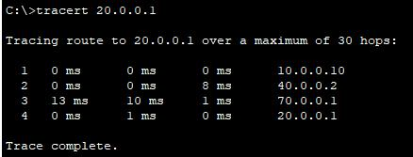

**DISCUSSION**

In this experiment, we designed and implemented a network topology using Cisco Packet Tracer involving multiple routers, switches, and PCs. Each PC was connected to a router via a switch, and the routers were interconnected using serial cables. Initially, IP addresses were manually assigned to router interfaces, and default gateways were set for the PCs. However, attempts to communicate across different networks using the ping command failed, resulting in a "Destination host unreachable" message. This issue arose because routers, by default, only recognize directly connected networks and lacked information about remote networks. To address this, static routing was configured on each router by manually defining specific routes to reach other networks. Once the static routes were in place, the connectivity tests using ping were successful, confirming that inter-network communication was established. Furthermore, the tracert command was used to observe the path packets took through the network, verifying that data was being correctly routed through the intended routers.

**CONCLUSION**

This experiment demonstrated the importance and functionality of static routing in a multi-router network environment. By manually configuring static routes, we enabled effective communication between devices on different networks. The successful results from both ping and tracert tests validated the correctness of our routing configuration. Overall, the experiment enhanced ourunderstanding of how routers forward packets and the significance of routing tables in managing network traffic.